|  |
| --- |
|  |
| Performance Testing Mentoring Program 2020#1  Task 1 report |

Contents

1. Summary 3

2. Actions 3

2.1. Test run#1 – Smoke test with 10 users 3

3. Conclusion 3

# Summary

Was created simple script to open Home page, open Contacts page with 10 users(role: anonymous). Monitoring was configured and git repositories were created.

# Actions

## Test run#1 – Smoke test with 10 users

* Repository for Jmeter scripts and reports was created. Another [repository](https://github.com/diNovitska/BlogEngineFiles) for BlogEngine also was created.
* Run parameters fot test (10 threads, rum-up period – 20s, test duration – 20s). Here is [repository](https://github.com/diNovitska/BlogEngine/tree/master/TASK1) with Jmeter script and pre-condition for this task(creation of ~10 users);
* Influx db collects data from Jmeter, virtual machine and machine with which I load a blog. Basic metrics was setup and reports are presented in Grafana.
* Server metrics as screenshot during the test is presented below. To see all graphics please click here

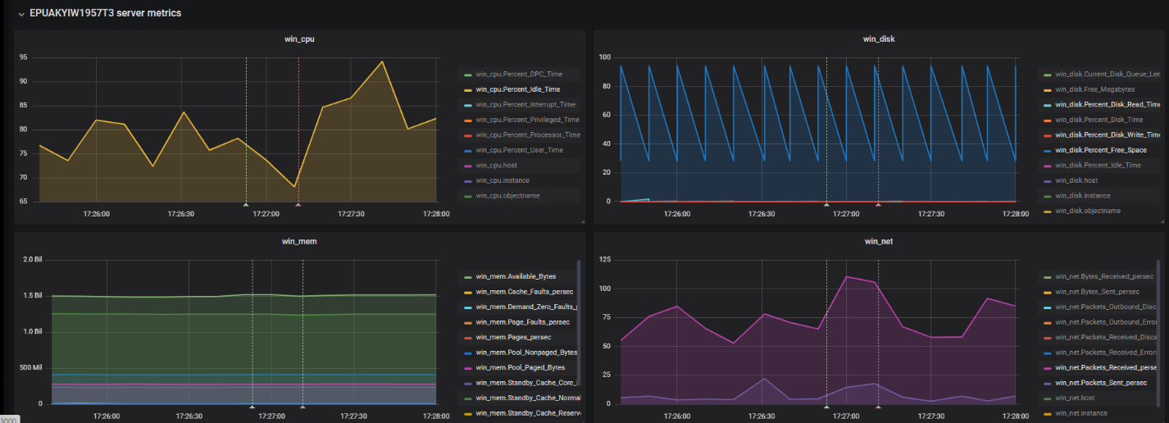

* JMeter run results as screenshot

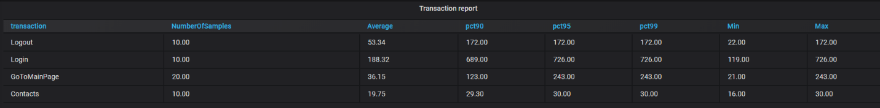

# Conclusion

10 users logged in to the system for 20 seconds do not significantly affect application performance